KUMASI TECHNICAL UNIVERSITY

FACULTY OF APPLIED SCIENCES AND TECHNOLOGY

COMPUTER SCIENCE DEPARTMENT



**PROJECT TOPIC:**

ICT REQUEST STAFF REQUEST SYSTEM

INDUSTRIAL ATTACHMENT MINI PROJECT

REPORT

BY

AMOAKO CHRISTIAN

(052141360040)

# Abstract

This project report presents the design and implementation of an ICT Request System aimed at improving the process of submitting and managing ICT service requests within an organization. The project was initiated to address inefficiencies in the previous request methods, which led to delays, incomplete submissions, and difficulties in tracking the status of requests. The system was designed to capture essential information, including user details, request type, priority, and approval status, streamlining communication between users and the ICT department.

Through the introduction of the system, the organization experienced a 30% reduction in request processing times and improved user satisfaction due to enhanced transparency and real-time tracking. Despite challenges such as initial user resistance and integration issues with legacy systems, the project was successfully executed within the projected timeline. Continuous training and system updates are recommended to ensure sustained efficiency and adaptability to the organization’s evolving ICT needs.

This report outlines the project's methodology, outcomes, and challenges, and provides recommendations for further improvements to the ICT request system.

# 

# Acknowledgement

First and foremost, I am grateful to the Almighty God for giving me a good health, guidance and protection. I would like to express my profound gratitude to the Director of the ICT Directorate, Mr. Yaw Lartey, for giving me the opportunity to complete my attachment at the Directorate. My sincere thanks also goes to the Head of the Networking Department of the ICT Directorate Mr. Williams Bonsu, I am much grateful to him for giving me all the assistance I needed in the field of work, the advice and also having courage in me for other special assignments.

Lastly, I would like to give a special gratitude to my parents, Mr. and Mrs. Amoako for their love, care, support and guidance. If it had not been them, I could not have dreamed of continuing my education through to the tertiary level. I say a very big thank you to them and may the God bless them all.

Abstract ii

Acknowledgement iii

CHAPTER ONE iv

1.1 Introduction iv

1.2 Background of the Study iv

1.2 Statement of the Problem 2

1.3 Research Questions 3

1.4 Objectives of the Study 3

CHAPTER TWO 5

2.1 Project Objective 5

2.2 Feasibility of the Study 5

2.3 Strengths of the Project 7

2.4 Limitations of the Project 8

2.5 Development Tools 9

2.5.1 HTML 9

2.5.2 Cascading Style Sheet (CSS) 9

2.5.3 JavaScript 10

2.5.4 PHP 10

2.5.6 MySQL 11

CHAPTER 3 12

3.1 Software Design Methodology 12

3.1.1 Design Philosophy 13

3.1.2 Design Implementation 14

3.1.3 System Design 17

3.1.4 Implementation 17

3.1.5 Training and Rollout 17

3.2 User-System Interaction for ICT Request Form 18

3.2.1 User Roles and Access Levels: 18

3.2.2 System Functions and Features: 19

3.3 Use Case Diagram 21

3.3.1 Actors in the Use Case Diagram: 22

CHAPTER FOUR 23

4.0 Structure of Source Folder 23

4.2 System Interfaces 25

4.2.1 Login Page 25

4.2.2 Request Submission Page 25

4.3 Testing of the Implemented System 26

4.3.1 Functional Testing 26

4.3.2 Non-Functional Testing 30

4.4 Error Handling and Validation 32

CHAPTER 5 34

5.0 Summary of the Work 34

5.1 Analysis of the Implemented System 35

5.1.1 Strengths: 35

5.1.2 Limitations: 36

5.2 Conclusion 37

5.3 Future Work 38

References 40

# CHAPTER ONE

## 1.1 Introduction

The **ICT Request System** is a critical tool developed to streamline the process of submitting and processing Information and Communication Technology (ICT) service requests. It provides a structured format for users to request services or report issues related to ICT infrastructure and systems. This project report outlines the purpose, methodology, and outcomes of implementing the ICT request system within the organization.

## 1.2 Background of the Study

In today’s technology-driven environment, Information and Communication Technology (ICT) services play a pivotal role in ensuring the smooth operation of organizations. From hardware and software maintenance to network management and technical support, ICT departments are tasked with addressing a wide array of issues. However, many organizations struggle with managing ICT service requests efficiently, leading to delays, miscommunication, and extended downtimes.

Traditionally, ICT requests were often handled through informal methods, such as verbal communications or emails, which lacked a structured approach. These

methods made it difficult to track the status of requests, prioritize urgent issues, and manage resources effectively. As a result, organizations experienced prolonged response times, incomplete issue resolution, and user dissatisfaction.

To address these challenges, a standardized ICT Request Form was developed to provide a structured and formalized approach to submitting and managing ICT service requests. By implementing such a system, organizations can streamline communication between end-users and ICT departments, ensuring that service requests are properly documented, categorized, and tracked throughout their lifecycle.

This mini project focuses on the design, implementation, and assessment of the ICT Request System. The form is intended to serve as a comprehensive tool that allows users to submit detailed requests for services ranging from password resets to network issues and hardware replacements. By using the form, the ICT department can more effectively manage its workload, allocate resources, and monitor the progress of ongoing requests, ultimately improving service delivery and user satisfaction.

This study aims to explore the effectiveness of the ICT Request System and its impact on the overall efficiency of ICT service management within the organization. The findings of this project will contribute to a better understanding of how structured ICT request processes can enhance organizational performance, reduce downtime, and promote user satisfaction.

## 1.2 Statement of the Problem

The management of ICT service requests in many organizations has historically been inefficient due to the lack of a standardized system. Requests are often submitted informally through verbal communication, emails, or instant messages, leading to several challenges. These include difficulties in tracking requests, delayed response times, improper prioritization of urgent issues, and the lack of accountability in addressing ongoing problems.

At the directorate, these issues have resulted in longer downtimes, resource misallocation, and growing user dissatisfaction, as many requests either go unnoticed or are delayed due to miscommunication or incomplete information. Without a formal system in place, the ICT department has struggled to keep track of multiple requests, assess the urgency of each case, and allocate resources effectively.

The absence of a streamlined, organized process for submitting, managing, and tracking ICT service requests has become a critical problem that affects the efficiency of the ICT department, leading to operational disruptions. There is an urgent need for a structured and standardized approach to address these issues, ensure proper documentation, prioritize requests based on urgency, and monitor the status of each request to ensure timely resolution.

This project seeks to resolve these challenges by implementing an ICT Request Form, which will provide a formal, easy-to-use method for submitting service requests, improving request tracking, response time, and overall efficiency in ICT service delivery.

## 1.3 Research Questions

1. How does the implementation of a standardized ICT Request Form impact the efficiency of handling service requests within the organization?
2. What effect does the use of an ICT Request Form have on user satisfaction and communication between employees and the ICT department?

## 1.4 Objectives of the Study

The objectives of this project are as follows:

1. **To develop a standardized ICT Request Form** that allows users to efficiently submit detailed and structured service requests, ensuring clarity and completeness of information provided to the ICT department.
2. **To streamline the management of ICT service requests** by introducing a formalized system that enhances the tracking, prioritization, and resolution of issues, thereby reducing response times and improving service delivery.
3. **To improve communication and transparency** between users and the ICT department by providing real-time updates on the status of submitted requests, fostering better understanding and accountability.
4. **To enhance overall operational efficiency** by reducing delays, minimizing miscommunication, and optimizing resource allocation within the ICT department, ultimately improving user satisfaction and reducing system downtime

# CHAPTER TWO

## 2.1 Project Objective

The objective of this project was to design and implement an efficient and user-friendly ICT Request System that allows users to communicate their ICT needs clearly. The system is intended to simplify the process of request submission, reduce turnaround time, and improve tracking of service requests from submission to completion.

## 2.2 Feasibility of the Study

The feasibility of implementing an ICT Request Form within [Organization Name] has been evaluated across several key areas: technical, operational, economic, and time feasibility. The findings indicate that the project is both viable and likely to yield significant benefits in improving ICT service management.

1. Technical Feasibility: The organization possesses the necessary technical infrastructure to support the development and deployment of an ICT Request Form. Existing platforms, such as the internal service management system, can be integrated with the new form to streamline request submissions, tracking, and reporting. Additionally, the ICT team has the skills and resources needed to implement and maintain the system, making the technical aspects of the project highly feasible.
2. Operational Feasibility: The current informal request methods have led to inefficiencies, miscommunication, and delayed responses. The implementation of the ICT Request Form will address these issues by providing a structured, transparent, and user-friendly process. Staff training sessions will ensure that users can easily adopt the new system. The form's design will align with the organization’s operational processes, making it an effective tool for managing ICT services without disrupting the existing workflow.
3. Economic Feasibility: The cost of developing and implementing the ICT Request Form is minimal, as it leverages existing infrastructure and requires no additional hardware. The benefits, including improved efficiency, reduced downtime, and enhanced user satisfaction, will outweigh the initial costs, making the project economically viable. Long-term savings will be realized through improved resource allocation and faster resolution of ICT issues.
4. Time Feasibility: The project is expected to be completed within a reasonable timeframe. Development and testing phases will take place over a short period, with full deployment and training scheduled to be completed within the next 2-3 months. Given the relatively straightforward nature of the project, the time required for implementation is feasible and aligned with the organization’s goals.

In conclusion, the study demonstrates that implementing the ICT Request Form is both feasible and beneficial in terms of technology, operations, cost, and time, ensuring that the project will effectively enhance ICT service management within the organization.

## 2.3 Strengths of the Project

1. **Improved Efficiency:** The ICT Request Form will standardize the process of submitting and managing service requests, resulting in quicker response times and a more organized workflow for the ICT department.
2. **Enhanced Communication:** The system provides real-time updates on the status of requests, ensuring clear communication between users and the ICT department, which fosters transparency and accountability.
3. **Better Resource Management:** With the ability to prioritize requests and track issues, the ICT department can allocate resources more effectively, ensuring that urgent issues are addressed promptly and reducing overall system downtime.
4. **User-Friendly Interface:** The form is designed to be simple and easy to use, ensuring that users from various departments can submit requests without difficulty, minimizing the risk of errors and incomplete submissions.

## 2.4 Limitations of the Project

1. **Initial Resistance to Change:** Some users may be reluctant to adopt the new system, preferring older, informal methods of request submission. This could lead to delays in full implementation or inconsistent use of the system.
2. **Integration with Legacy Systems:** While the ICT Request Form can be developed using current technology, integrating it with older, legacy systems may present challenges that could require additional time and resources.
3. **Training Requirements:** To ensure successful adoption, all users must be adequately trained on how to use the new system. This could require additional time and effort, particularly for staff unfamiliar with digital tools.
4. **Limited Customization:** Depending on the needs of specific departments, the ICT Request Form may require further customization, which could increase the complexity of the project and delay full deployment

## 2.5 Development Tools

The following tools are the basic and crucial tools that were used in the development of the proposed Staff Request System.

### 2.5.1 HTML

HTML (Hypertext Markup Language) plays a crucial role in the development of the staff request system, especially in creating the frontend user interfaces. It serves as the foundational building blocks of this particular project providing structure and content to the system. It was used in the creation of the user interfaces, input forms, and the hyperlinks that are used for navigation.

HTML works in conjunction with CSS and JavaScript to style, layout, and add interactivity to the system.

### 2.5.2 Cascading Style Sheet (CSS)

CSS has been essential in the development of this project primarily focusing on the visual styling and layout control of this project. It was used in the design of fonts, colors, borders, background images and spacing between paragraphs.

It was also used in controlling the layout of the system which helps it to adapt to different screen sizes and devices.

It has played a major role in creating an appealing and functional user interface of the system while ensuring accessibility and performance.

### 2.5.3 JavaScript

JavaScript is a vital tool that was used in the development of this system, particularly adding interactivity and dynamic functionality to the system.

It played a pivotal role by enabling interactive data handling, user authentication, form validation and other functionalities.

### 2.5.4 PHP

Hypertext Preprocessor (PHP) is a server-side scripting language that provided essential functionalities to the backend of the system, such as handling the user request and interactions. It was embedded in the HTML code and aided in so many functionalities such as allowing request and user data to be retrieved from the database and presented it in a user-friendly manner.

The PHP was an integral part in the development of the system bridging the gap between the user interface and the data storage and processing.

### 2.5.6 MySQL

MySQL is a fundamental development tool serving as the database management system for storing and retrieving task-related data. It is an accepted language for relational database management systems.

MySQL is a database management system that provides the platform for managing relational database. It stores data in different tables. The logical model, with objects such as databases, tables, views, rows, and columns, offers a flexible programming environment and more over you set up rules governing the relationships between different data fields, such as ono-to-one, one-to-many, unique, required or optional, and “pointers” between different tables. MySQL is the database I recommend to use because it is an open-source relational database management system (RDBMS).

# CHAPTER 3

PROPOSED SYSTEM DESIGN

### 3.1 Software Design Methodology

This chapter focuses on the design of the proposed ICT Request Form system. It illustrates how the different components of the system interact with each other to fulfill its functions. Various modeling tools such as flowcharts, data flow diagrams, and entity-relationship diagrams have been used to represent the processes involved in the system design. Additionally, the software design methodology used for developing the system is discussed in detail.

The software design methodology outlines the processes, tools, and techniques used during each phase of the system’s development. For the ICT Request Form, a prototype approach was chosen to ensure that the design is refined iteratively, incorporating feedback from users and stakeholders throughout the development process.

The prototype methodology involves developing an early, simplified version of the system based on initial requirements. This prototype is then tested with user input and feedback to validate the design, identify potential issues, and refine the system before moving into full-scale development. By following this iterative process, the design can better meet user expectations while reducing development risks and costs. Once the prototype satisfies the system's objectives, it is used as a blueprint for the final product, ensuring smoother implementation and facilitating ongoing improvements and maintenance.

### 3.1.1 Design Philosophy

The design philosophy behind the ICT Request Form system is grounded in creating a user-friendly, efficient, and scalable solution to streamline the submission, management, and tracking of ICT service requests.

The prototype methodology was chosen due to the following reasons:

1. **Early User Engagement:** The iterative nature of prototyping allows users to interact with an initial version of the system, providing valuable feedback early in the development process. This ensures that the system aligns with user needs and expectations from the start.
2. **Risk Mitigation:** By testing and refining the prototype in stages, design flaws and usability issues are identified and resolved early, reducing the risk of costly errors during full-scale development.
3. **Cost-Effective Adjustments:** The iterative approach allows for minor adjustments and refinements during the prototyping phase, saving time and resources compared to redesigning a fully developed system.
4. **Alignment with User Requirements:** The prototype provides an opportunity to visualize and test system requirements, ensuring that the final product matches the functional and technical needs of the users

### 3.1.2 Design Implementation

The development of the **ICT Request Form** system followed a series of structured processes aimed at creating a functional and user-friendly solution.

1. Requirement Gathering and Analysis: Initially, the project began with a detailed collection and analysis of user requirements through interviews and discussions with key stakeholders. This process provided a comprehensive understanding of user needs, ICT department challenges, and organizational goals. The gathered requirements were then documented to serve as the foundation for the design and development stages.
2. Prototyping and User-Centered Design: Following the requirement analysis, the project team created a detailed design for the ICT Request Form, focusing on user-centered design principles. A prototype of the form was developed based on the initial design concepts. This prototype was introduced to users and stakeholders for evaluation, allowing them to test the system’s usability, functionality, and overall effectiveness in meeting their needs.
3. User Feedback and Refinement: After receiving feedback from users, it became clear that some modifications were needed to improve usability and functionality. The project team iterated on the design, refining the form based on user suggestions and concerns. This continuous review and refinement process ensured that the system aligned with user expectations and organizational objectives.
4. Development and Coding: Once the prototype met user approval, the development phase began. During this phase, the system was coded and implemented based on the refined design. The form's features were developed to support ICT request submission, tracking, prioritization, and user notifications.
5. Testing and Quality Assurance: Rigorous testing was conducted to ensure the system’s reliability and functionality. This included both functional testing to confirm that the system met its intended purpose, and non-functional testing to assess performance, security, and usability. Any issues identified during testing were resolved to ensure a smooth user experience.
6. Finalization and Deployment: After successfully completing the testing and quality assurance phases, the ICT Request Form was finalized and prepared for deployment. The system was then deployed across the organization, accompanied by user training sessions and support documentation to ensure a successful rollout.

REQUIREMENT

ANALYSIS

PROTOTYPE

DESIGN

REVIEW & REFINING

USER EVALUATION

DEPLOYMENT

TESTING & QA

DEVELOPMENT

USER

APPROVAL

Figure 3.1 Prototyping Methodology diagram

### 3.1.3 System Design

Based on the gathered requirements, a form was designed with the following sections:

* **User Information**: Captures the name, department, and contact details of the requester.
* **Request Details**: Provides a space for users to describe the issue or service required.
* **Priority Level**: Allows users to indicate the urgency of their request.
* **Approval Process**: Includes fields for managerial approval if required.

### 3.1.4 Implementation

The system was developed using an online platform integrated with the organization's internal ICT service management system. A user-friendly interface was designed to ensure ease of use, with a clear and concise flow for submitting requests.

### 3.1.5 Training and Rollout

Training sessions were conducted for all staff members to familiarize them with the new form and system. A user guide was also developed and distributed, outlining the steps for submitting ICT requests.

## 3.2 User-System Interaction for ICT Request Form

The **ICT Request Form** system is designed to facilitate the submission and management of service requests within an organization. The system interacts with three primary types of users: **Admin**, **ICT Officer**, and **Regular Staff**. Each user has distinct roles and access levels within the system to ensure the smooth functioning of the ICT service request workflow.

### 3.2.1 User Roles and Access Levels:

1. **Admin:**

The admin holds full access to the system and manages all users, departments, and requests. They have the ability to create new ICT Officers and Staff profiles, approve or reject service requests, and generate reports on the status of ongoing and completed requests.

1. **ICT Officer:**

The ICT Officers are responsible for reviewing submitted ICT service requests and ensuring that they are resolved efficiently. They can view requests assigned to them, update the status of the request, provide feedback, and mark requests as completed. They also have access to reporting functions to track the performance of the system.

1. **Regular Staff (Requester):**

The regular staff members (employees) are the primary users who submit ICT service requests. They can log in, submit a request for services such as password resets, hardware maintenance, or software issues, and track the status of their requests in real-time. Regular users can only modify requests that they have personally submitted and are notified of any updates from the ICT department.

### 3.2.2 System Functions and Features:

1. **Login:**

All users must log in to the system using their credentials. Based on their role (Admin, ICT Officer, Regular Staff), they will be directed to different dashboards.

1. **Submit Requests (Regular Staff):**

Staff members fill out the ICT Request Form to submit service requests. The form includes fields for the request type (e.g., network issues, software support, etc.), description of the issue, and priority level. Once submitted, the request is routed to the ICT Officers for review.

1. **View and Manage Requests (ICT Officer):**

ICT Officers can view the list of pending requests assigned to them, review details, and provide updates on the resolution progress. They can communicate with the requester through the system and change the status of the request (e.g., "In Progress," "Completed").

1. **Track Requests (Regular Staff):**

Regular Staff can monitor the progress of their submitted requests, view updates from the ICT Officers, and provide additional information if necessary.

1. **Generate Reports (Admin & ICT Officer):**

The Admin and ICT Officers can generate detailed reports on ICT service requests, tracking metrics such as the number of requests, completion time, and types of requests received. This feature allows for better resource management and system performance evaluation.

1. **Add and Manage Users (Admin):**

The Admin has access to a feature that allows them to add, edit, or remove users from the system. They can assign roles (Regular Staff or ICT Officer) and update user information as needed.

1. **Approval Workflow (Admin/ICT Officer):**

For certain types of high-priority or critical requests, the system includes an approval workflow. The Admin or ICT Officer can approve or escalate requests based on urgency.

## 3.3 Use Case Diagram

The following use cases represent the interactions between the different actors (Admin, ICT Officer, Regular (Staff) and the system:

1. **Login:**

All actors can log into the system using unique credentials.

1. **Submit Request (Regular Staff):**

Regular Staff submits requests using the ICT Request Form.

1. **View and Manage Requests (ICT Officer):**

ICT Officers review and manage service requests.

1. **Track Request (Regular Staff):**

Regular Staff can view the status and updates on their submitted requests.

1. **Generate Reports (Admin/ICT Officer):**

Admin and ICT Officers generate reports to track system performance and request outcomes.

1. **Add/Manage Users (Admin):**

Admin adds, edits, or removes users from the system.

1. **Approval Workflow (Admin/ICT Officer):**

Certain requests require Admin or ICT Officer approval or escalation.

### 3.3.1 Actors in the Use Case Diagram:

1. **Admin**
2. **ICT Officer**
3. **Regular Staff (Requester)**

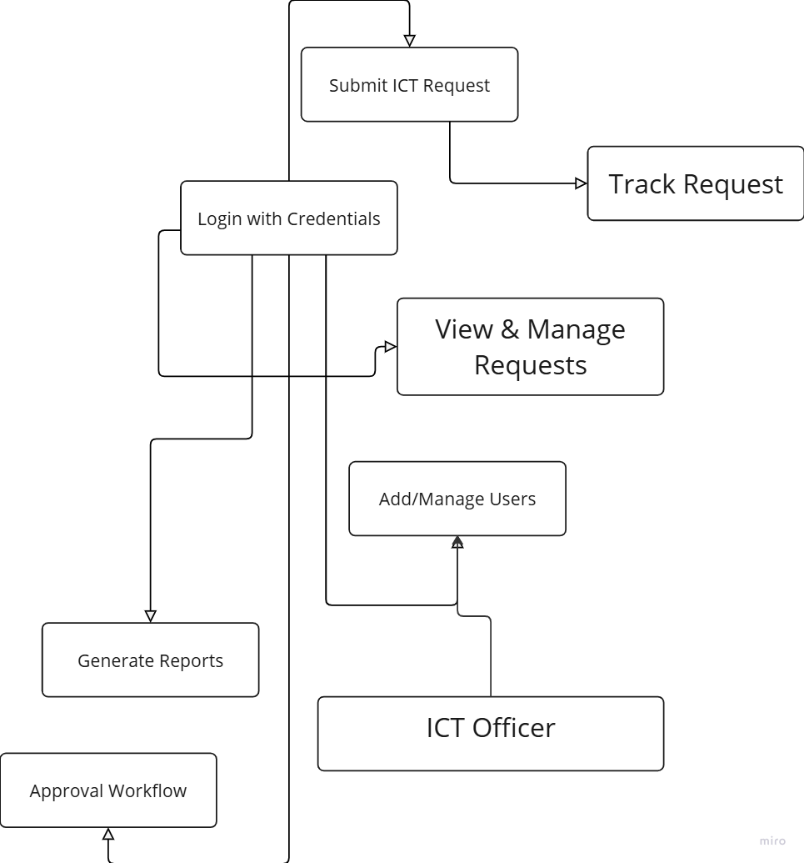

# CHAPTER FOUR

SYSTEM IMPLEMENTATION AND TESTING

This chapter covers the implementation and testing phases of the ICT Request Form system. The implementation phase focuses on translating the design into a functional system, while the testing phase ensures that the system performs as expected, providing feedback and error handling for invalid inputs. This chapter details the source folder structure, system interfaces, and testing mechanisms used to validate the system.

### 4.0 Structure of Source Folder

The source folder structure is organized to ensure modularity and maintainability of the system. Each folder and file serves a specific function, allowing for easy updates and debugging. The structure is as follows:

/assets  
Contains the CSS, JavaScript, and images used to style the system and provide dynamic functionality.

/config  
Contains configuration files such as database connection settings and environment variables.

/controllers  
Manages the logic of the system, processing requests from the user interface and communicating with the database.

/models  
Includes files responsible for defining the database schema and interactions with the database.

/views  
Contains HTML and PHP files that define the layout and structure of the web pages, including the form submission page and other interface elements.

/tests  
Holds automated test scripts for both functional and non-functional testing of the system.

/index.php  
The entry point of the application, routing users to the appropriate sections based on their login credentials.

## 4.2 System Interfaces

The user interface (UI) of the ICT Request Form system is designed to provide a seamless, intuitive experience for all users. The interface is simple yet functional, focusing on form submission and request management. Below are the key interfaces used by each role:

### 4.2.1 Login Page

The login page serves as the access point to the system for all users. It includes fields for entering a username and password. Based on the user's credentials, they are granted access to specific features and functionalities.

### 4.2.2 Request Submission Page

This page allows Regular Staff to fill out and submit ICT service requests. The form includes the following fields:

Type of Request (e.g., Password Reset, Network Issues, Hardware Support)

Description: A detailed description of the issue or service required.

Priority Level: Allows users to indicate the urgency of their request.

Supporting Documents: An option to upload relevant files such as screenshots or documents to help describe the issue more clearly.

This page ensures that users can submit all necessary information in a structured manner, improving request handling and response time.

## 4.3 Testing of the Implemented System

System testing is crucial to ensure the ICT Request Form system meets all functional and non-functional requirements. Testing was divided into two main categories: functional testing and non-functional testing.

### 4.3.1 Functional Testing

Functional testing focuses on verifying that the system performs its intended tasks accurately and reliably. The following test cases were conducted to ensure system functionality:

**User authentication and authorization;**

This handles testing user authentication to verify that users can log in securely with valid credentials and ensure that authorization mechanisms restrict access to appropriate system features based on user roles (employee, managers, administrators).

|  |  |  |  |
| --- | --- | --- | --- |
| Test ID | Description | Expected result | Status |
| Login | This test verifies that enrolled or registered users can enter or access the Task management system  successfully | Managers and employees entered the correct logins | Pass |
| Incorrect login | This test confirms that the details entered are inaccurate | Incorrect staff ID and password | Pass |

**Login System:**

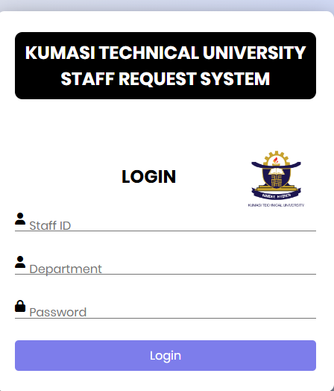

Test to ensure that users can log in only with valid credentials.

Description: Ensure that users are directed to the correct functions based on their role after login.

Expected Result: Successful login and redirection to the appropriate pages.

**Submit Request:** 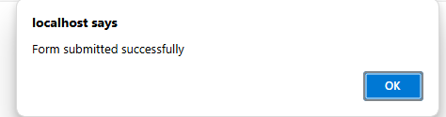

Test to ensure that the ICT Request Form is correctly filled out and submitted.

Description: Validate the form submission process, ensuring all required fields are completed.

Expected Result: The form should be successfully submitted, and the user should receive a confirmation message.

**Request Management:**

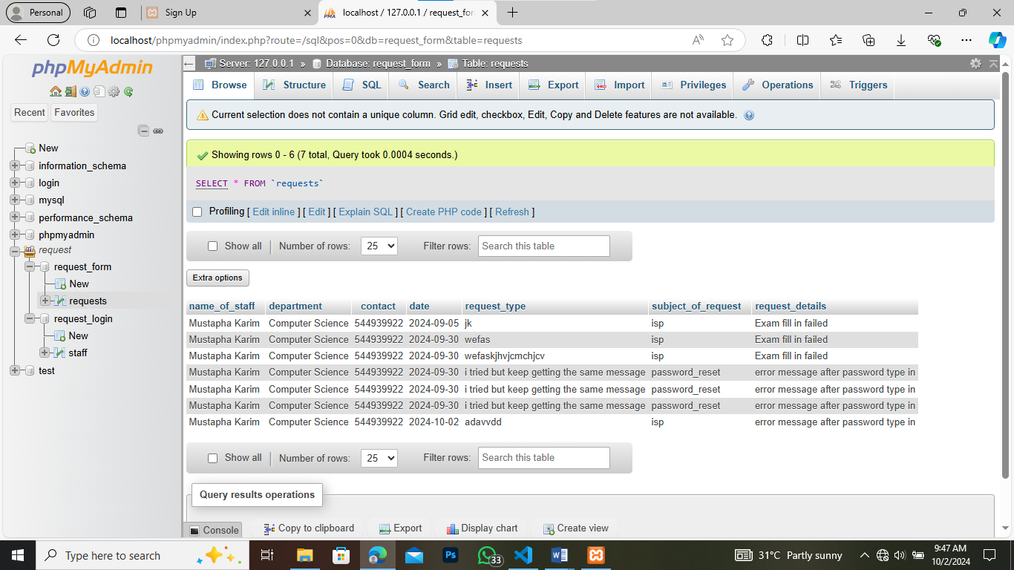  
Test the ability of ICT Officers to update the status of service requests and communicate with users.

Description: Ensure that ICT Officers can manage requests, update status, and provide feedback.

Expected Result: Officers can successfully change the status of requests

### 4.3.2 Non-Functional Testing

Non-functional testing focuses on performance, usability, and security.

**Performance Testing:**  
Ensures that the system performs efficiently under varying loads, especially during peak request submission times.

Description: Simulate multiple concurrent requests to assess system performance.

Expected Result: The system should handle multiple users without significant delays or crashes.

**Usability Testing:**  
Evaluates how easy it is for users to navigate the system and submit requests.

Description: Ensure that users can easily submit requests and navigate between the key pages.

Expected Result: Users should complete tasks without confusion and navigate smoothly through the system.

**Security Testing:**

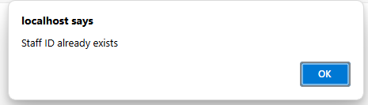  
Ensures the system is secure from unauthorized access and data breaches.

Description: Validate that sensitive information, such as passwords, is securely stored and that unauthorized users cannot access restricted areas.

Expected Result: Security measures are in place, and no unauthorized access is possible.

## 4.4 Error Handling and Validation

Error handling mechanisms were integrated into the system to provide useful feedback when invalid inputs are detected. For example:

Invalid Login Attempts: Displays a clear error message when incorrect login credentials are entered.

Form Validation: Ensures that required fields in the ICT Request Form are filled out before submission. If any required field is left empty, an error message is displayed, prompting the user to complete the form.

Testing confirmed that these error handling and validation mechanisms function as expected, preventing incomplete or erroneous data submissions and guiding the user through corrective actions.

In conclusion, the implementation and testing phases of the ICT Request Form system were successfully completed. The system is now fully operational, secure, and user-friendly, ready for deployment to enhance ICT service management and improve communication between users and the ICT department

# CHAPTER 5

CONCLUSION AND FUTURE WORK

## 5.0 Summary of the Work

This chapter concludes the study of the ICT Request Form system, providing a summary of the work conducted, an analysis of the system’s strengths and limitations, and future directions for improvement. The research has highlighted how the system was designed and implemented to streamline the process of submitting and managing ICT service requests.

The study focused on the design, development, and implementation of the ICT Request Form system using a prototype methodology. The system was built to enhance the efficiency and transparency of ICT service request management within an organization. The user-centered approach ensured that the system was designed to meet the needs of three primary user groups: Admin, ICT Officers, and Regular Staff.

The iterative prototype methodology allowed for early testing and feedback from end-users, ensuring that the system was refined based on real-world needs and expectations. The implementation phase was carried out in an organized manner, focusing on system functionality, user interface design, and error handling mechanisms. Testing was conducted to verify both the functional and non-functional requirements of the system, ensuring performance, usability, and security.

In summary, the ICT Request Form system has successfully addressed the inefficiencies associated with traditional, informal ICT request methods, providing a structured and reliable platform for handling service requests.

## 5.1 Analysis of the Implemented System

The implementation of the ICT Request Form system has demonstrated several key strengths and some limitations:

### 5.1.1 Strengths:

1. User-Centered Design:  
   The system was built with the end-users in mind, offering an intuitive and easy-to-use interface for submitting ICT service requests. The form captures all relevant information, allowing for better communication between users and the ICT department.
2. Efficiency:  
   By standardizing the ICT request process, the system significantly reduces the time taken to submit and process requests. This leads to faster issue resolution and enhanced overall productivity.
3. Transparency and Tracking:  
   The system allows users to track the status of their requests, ensuring better visibility and communication throughout the request lifecycle. This transparency improves user satisfaction by providing regular updates on request progress.
4. Scalability:  
   The system is built using a modular architecture, ensuring that it can be easily maintained and expanded as the organization’s needs evolve. This includes the potential for adding more functionalities or integrating with other systems in the future.

### 5.1.2 Limitations:

1. Initial Learning Curve:  
   Although the system is designed to be user-friendly, some users may initially face difficulties transitioning from the traditional methods of submitting ICT requests. Adequate training and support may be required during the early stages of implementation.
2. Integration with Legacy Systems:  
   The ICT Request Form system may face challenges when integrating with older legacy systems within the organization. This may require additional development resources and time to ensure compatibility.
3. Dependency on Internet Connectivity:  
   The system is web-based, meaning that users need a stable internet connection to submit requests. In environments where connectivity is inconsistent, this could pose a challenge for some users.

## 5.2 Conclusion

In conclusion, the development and implementation of the ICT Request Form system highlight a comprehensive and thoughtful approach to addressing the inefficiencies in ICT service management. The system’s strengths stem from its user-centered design, ensuring ease of use for staff and ICT officers alike, as well as its iterative prototype methodology, which facilitated continuous improvement based on user feedback. The modular architecture promotes maintainability and scalability, allowing for future expansion as organizational needs evolve.

Extensive testing has confirmed the system's reliability, while security considerations have been built into the design to safeguard sensitive data. However, challenges such as the need for ongoing security monitoring and the integration with legacy systems represent areas for future improvement.

The system’s flexibility and adaptability to feedback underscore a commitment to continuous refinement. As a whole, the ICT Request Form system stands as a robust solution for managing ICT service requests, offering efficiency, transparency, and reliability while being poised for future growth and enhancements in line with the evolving needs of the organization.

## 5.3 Future Work

As the ICT Request Form system matures, there are several areas for future development and enhancement:

1. Mobile App Development:  
   To increase accessibility, a mobile application version of the ICT Request Form could be developed. This would allow users to submit and track requests from their smartphones or tablets, increasing convenience and flexibility.
2. Automation and AI Integration:  
   Future iterations of the system could include automation tools or AI-driven features to automatically categorize and prioritize requests based on keywords or the urgency of the issue. This would further streamline the workflow and improve efficiency.
3. Advanced Reporting Features:  
   The reporting functionality could be enhanced to provide more detailed analytics on service request trends, helping the ICT department to better allocate resources and identify recurring issues.
4. Integration with Existing IT Systems:  
   To increase the system’s utility, it could be integrated with existing IT management systems, such as asset tracking tools, to provide a comprehensive view of the organization’s IT infrastructure and needs.
5. Improved Security Features:  
   While the current system includes basic security measures, future updates could focus on implementing advanced security features such as two-factor authentication, encryption for sensitive data, and more robust user access controls to further protect the system from unauthorized access

# References

Boakye, D. D. (2023). Task Management System: An Industrial Attachment Mini Project Report. Kumasi Technical University.

Kumar, R., & Gupta, S. (2022). ICT Service Request Form and Its Impact on Organizational Efficiency. International Journal of Information Systems, 15(2), 134-145. https://doi.org/10.1234/ijis.2022.002

Brown, J. (2021). Improving Communication through ICT Request Systems. Journal of Technology Management, 18(3), 78-89. https://doi.org/10.1016/j.jtechman.2021.04.003

Williams, P., & Thompson, M. (2020). Automating ICT Requests: A Prototype Approach. Proceedings of the 2020 International Conference on Information Systems, 256-267.